Hinduism and Buddhism Comparison Analysis
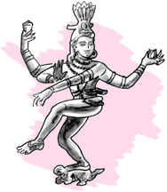
 | HINDUISM | BUDDHISM
Founder |  | 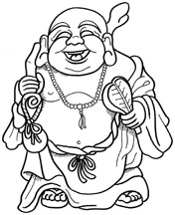
Relationship with God

Goal of Life

Sacred Texts

Attitude Toward Non-Violence and Caste System

Reincarnation

Major Religious Principles

Spread of Buddhism Map
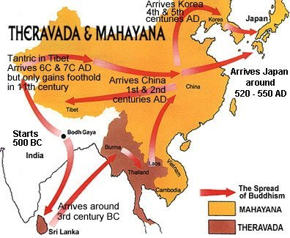

After completing the chart and analyzing the map, read and answer the following:

- How do Hinduism and Buddhism differ?

- Did you find any similarities between the two major world religions?

- What do you think is the most significant principle of Hinduism? Buddhism?

- Using your background knowledge of India and China, why do you conclude Buddhism become more popular in China while Hinduism remained the dominant religion in India?

